Hashtag Activism
Name
Institution
Date

Hashtag Activism
Hashtag activism refers to a term given to the latest trend of creating a hashtag for a certain cause, such as for a tragedy or issues in the world (Chiluwa & Ifukor, 2015). From another point of view, many people tend to see hashtags as a means of spreading awareness and helping a cause while others view it as a waste of time. In many settings, those who participate in hashtag activism are convinced that they can make a difference in the world simply by posting a hashtag to join the conversation online (Chiluwa & Ifukor, 2015). The hashtag is believed to have the ability to bring people together as a means to solve a common problem.
Part 1: Past Hashtag
One of the real hashtag activism campaigns is #BringBackOurGirls. This hashtag was predominantly used in April 2014 when several girls were kidnapped from a government secondary school in Nigeria. As argued, some girls escaped while others were still missing and hence bringing about the hashtag #BringBackOurGirls as an attempt to raise awareness and help to ease the situation. The hashtag was increasingly used in different social media platforms such as Facebook, Twitter, and Instagram. The figures bellow illustrated use of the hashtag from twitter:

Fig 1.1

Fig 1.2
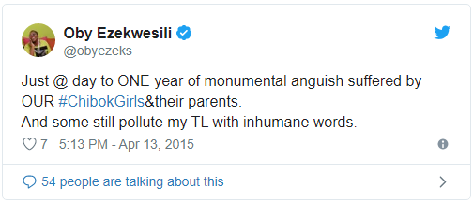
Fig 1.3
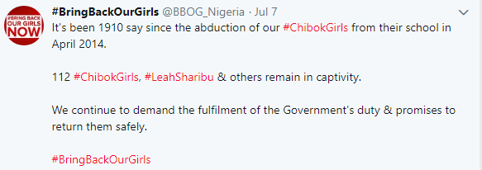
Fig 1.4
This hashtag gained global penetration. President Obama, his wife (Michelle) among other celebrities, was increasingly empathetic to the incident and they actively participated in sharing this hashtag activism. As a result, the campaign became an item of global attention, although it is failed to create a real change since it did not make the terrorist organization willing to surrender their case.
Part 2: Current Hashtag
#Trastag is one of the most current social activism hashtags which have gained popularity. The #Trashtag is said to have inspired people to clean up their parks. The hashtag comes out as a social, medical challenge to people across the globe convincing them to participate in cleaning up their parks, beaches, rivers, as well as urging their friends to get in the action. It is worth to assert that garbage hardly makes for a good for human. However, the #trashtag challenge encouraged people in the world to pose with heaps of trash bags. The hashtag has been complemented with the “wholesome memes” which challenge people to pose for before and after shots of areas in need of a good cleaning. Based on the #trashtag, majority of people were highly fascinated to carry out environmentally friendly practices. They took to the beaches, collecting up piles of cans as well as plastic bottles. Also, volunteers gathered to clean up their local parks as well as rivers while others tackled the trash alone. Overall, the #trashtag was quite reflective of the ideal environmental needs, and many people tried to resonate with it by taking the most effective initiatives to clean their surroundings. This hashtag is likely to create more change because it helps people to understand the importance of maintaining their environment while focusing on future benefits. Below are some examples of tweets based on #trashtag activism:
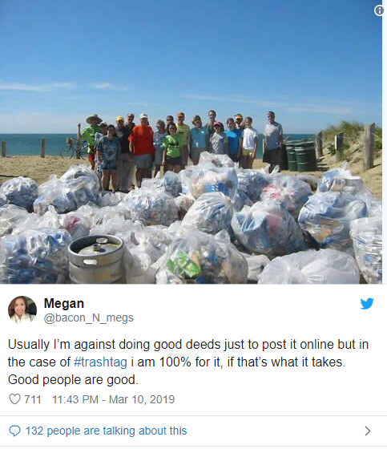

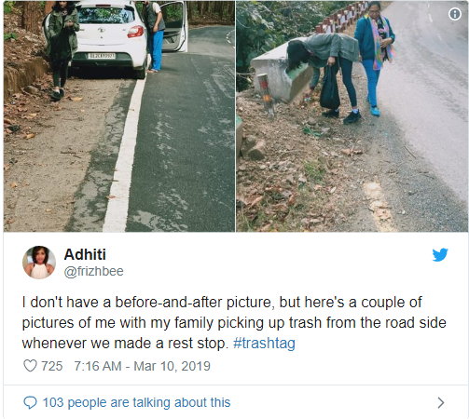

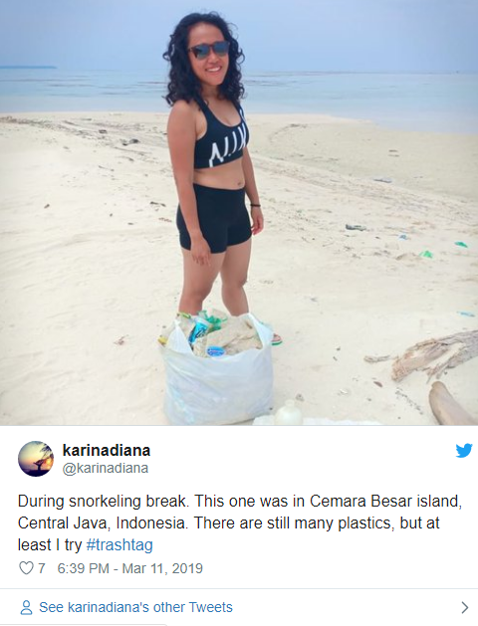

References
Chiluwa, I., &Ifukor, P. (2015). ‘War against our Children’: Stance and evaluation in# BringBackOurGirls campaign discourse on Twitter and Facebook. Discourse & Society, 26(3), 267-296.
Williams, S. (2015). Digital defense: Black feminists resist violence with hashtag activism. Feminist Media Studies, 15(2), 341-344.

